**Lab-Project 8: Cracking Linux Password Hashes with Hashcat**

**Getting Hashcat 2.00**

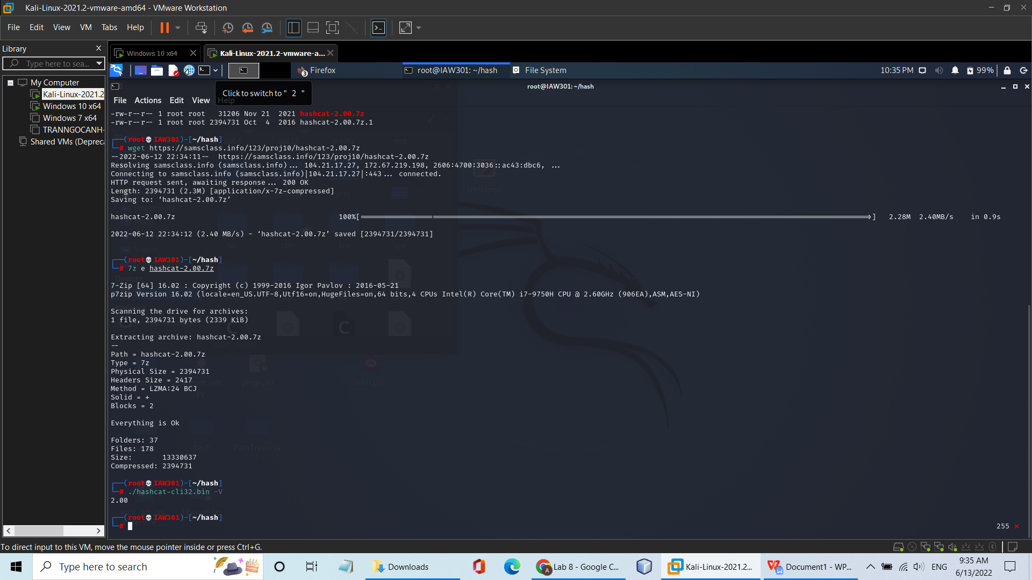

**Creating a Test User**

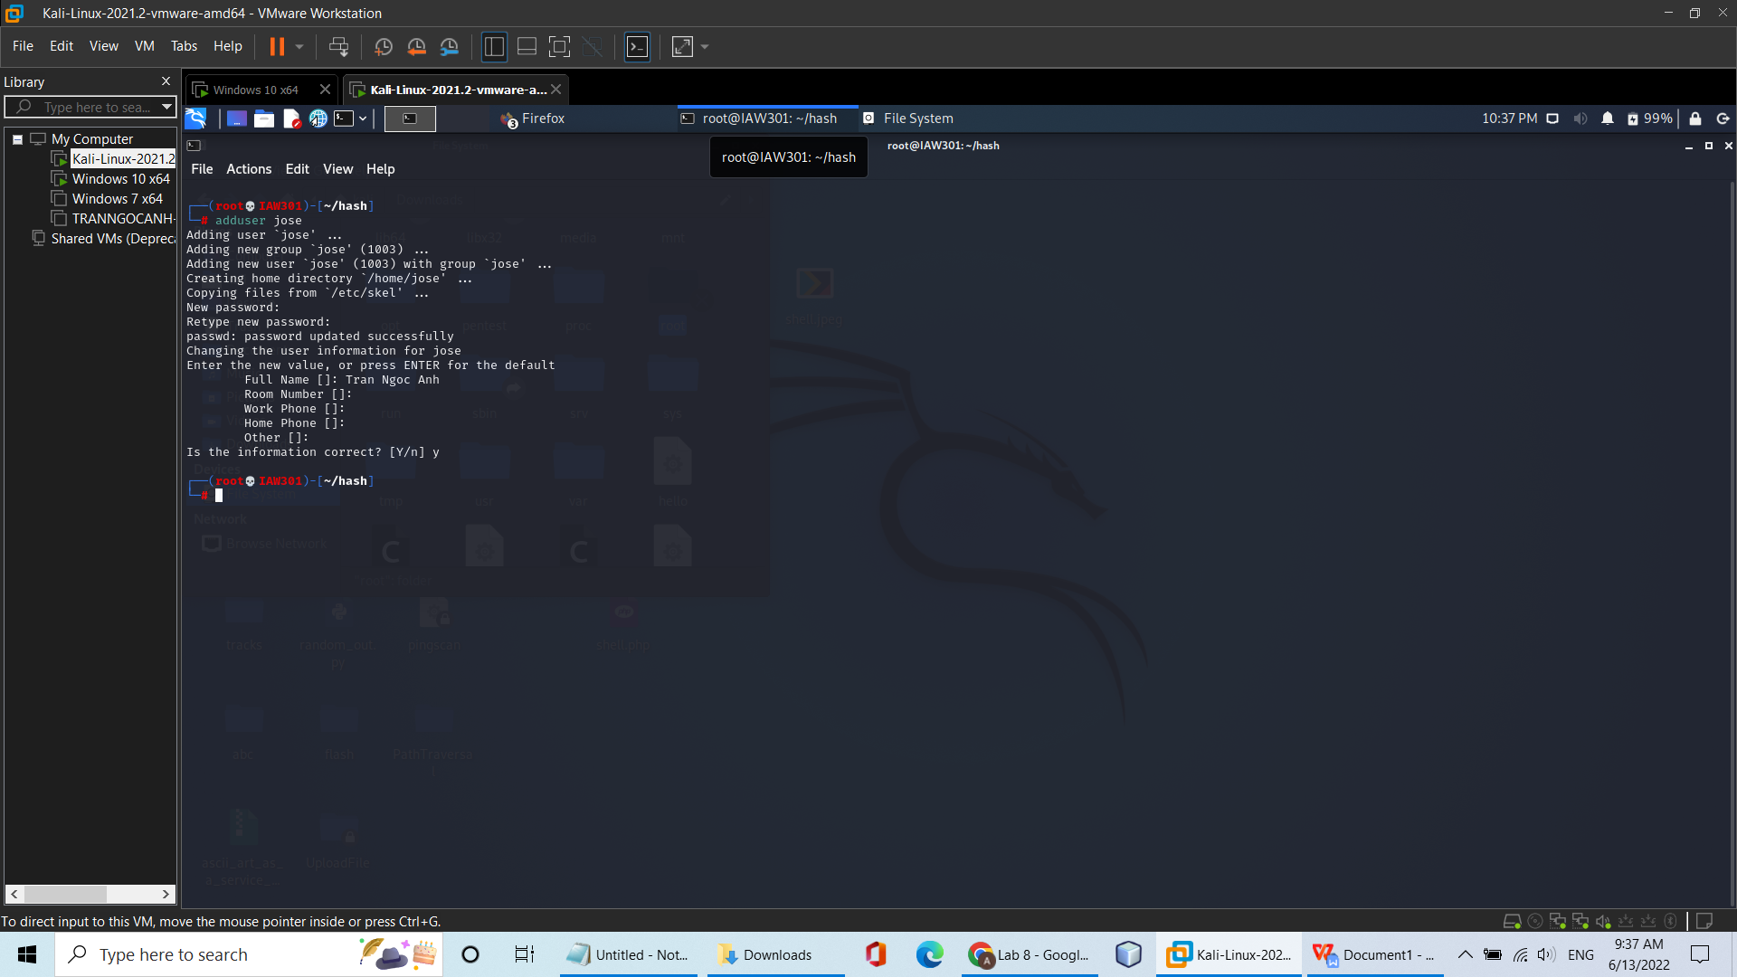

**Viewing the Password Hash**

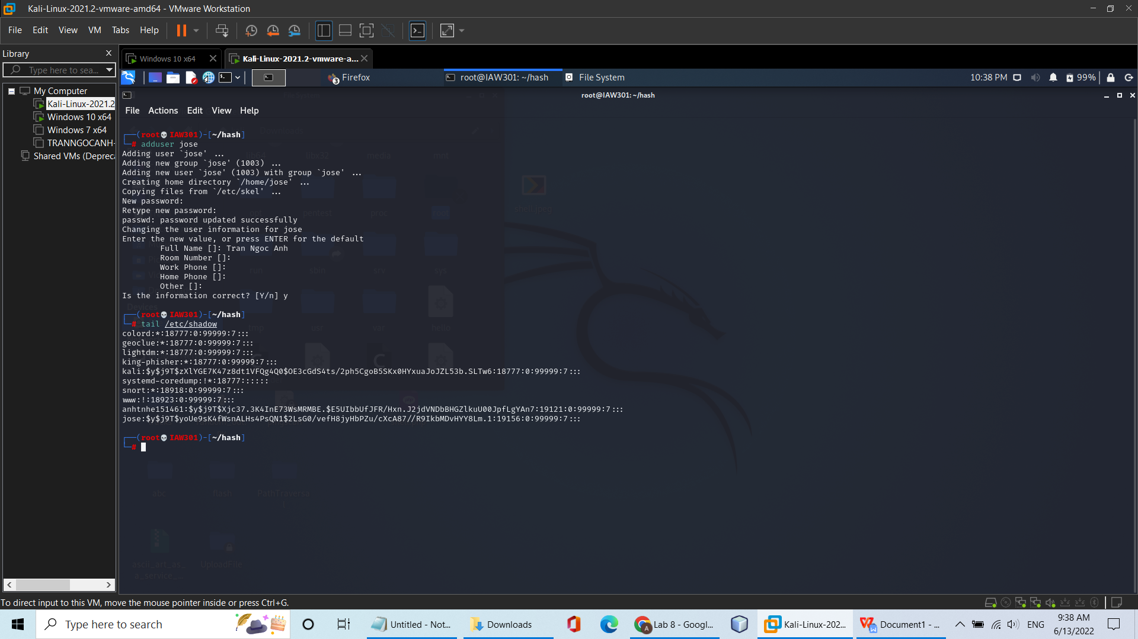

**Understanding the Hash Algorithm**

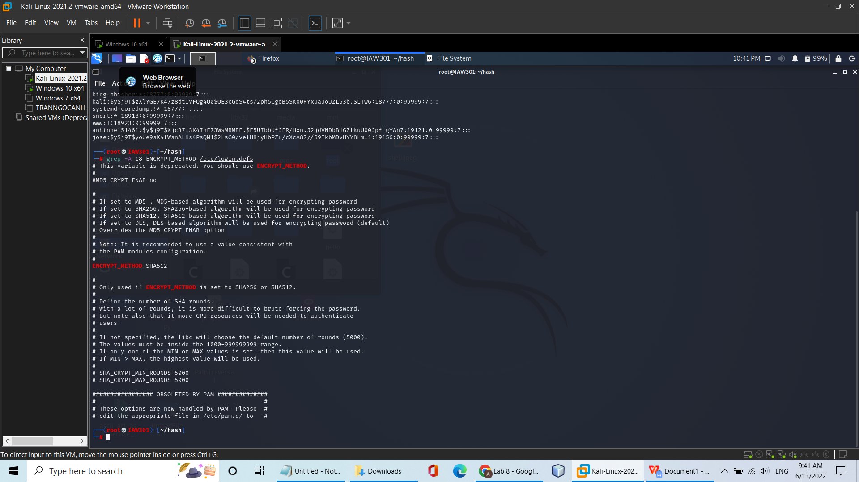

**Making a Hash File**

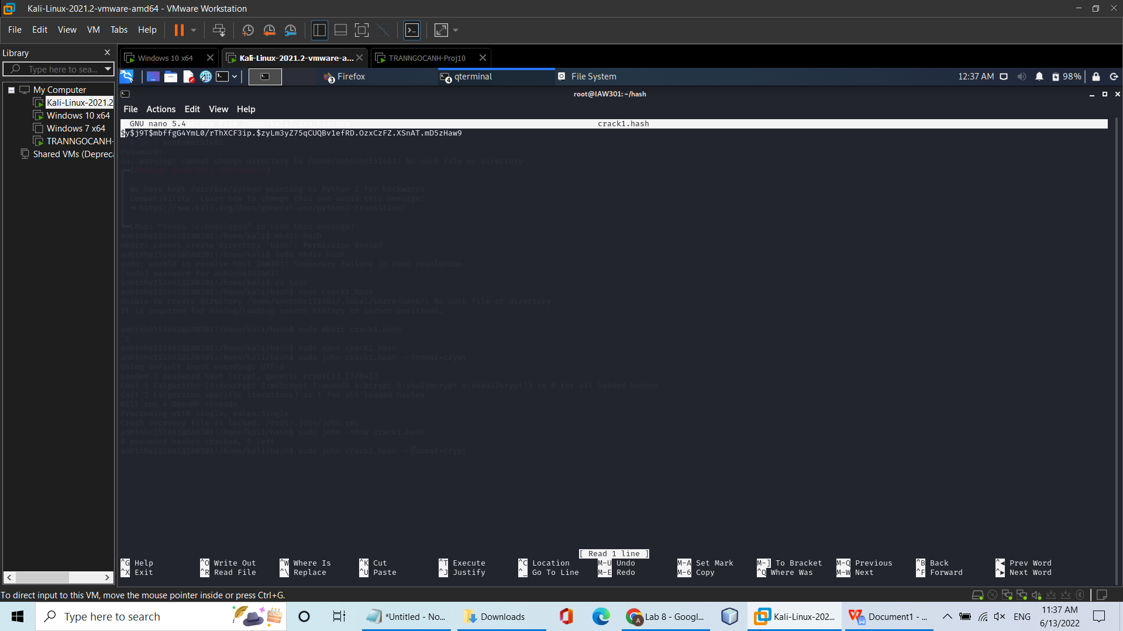

**Downloading a Wordlist**

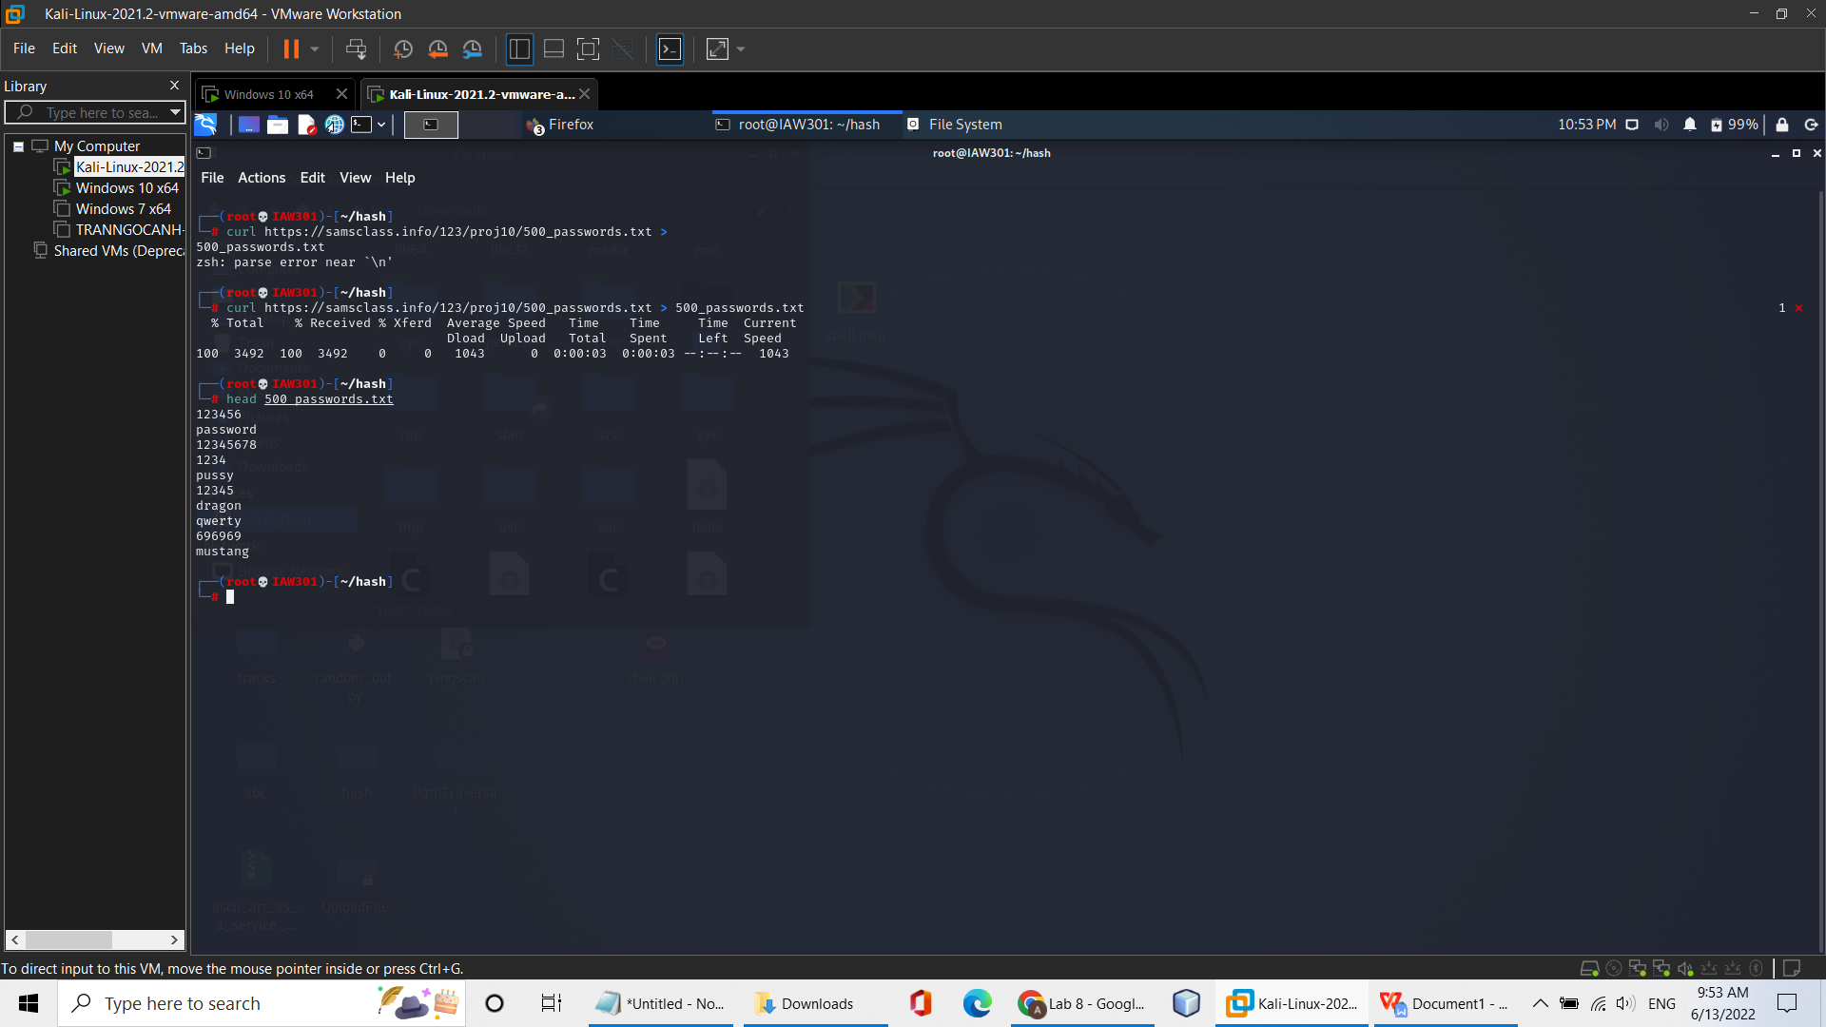

**Cracking the Hash**

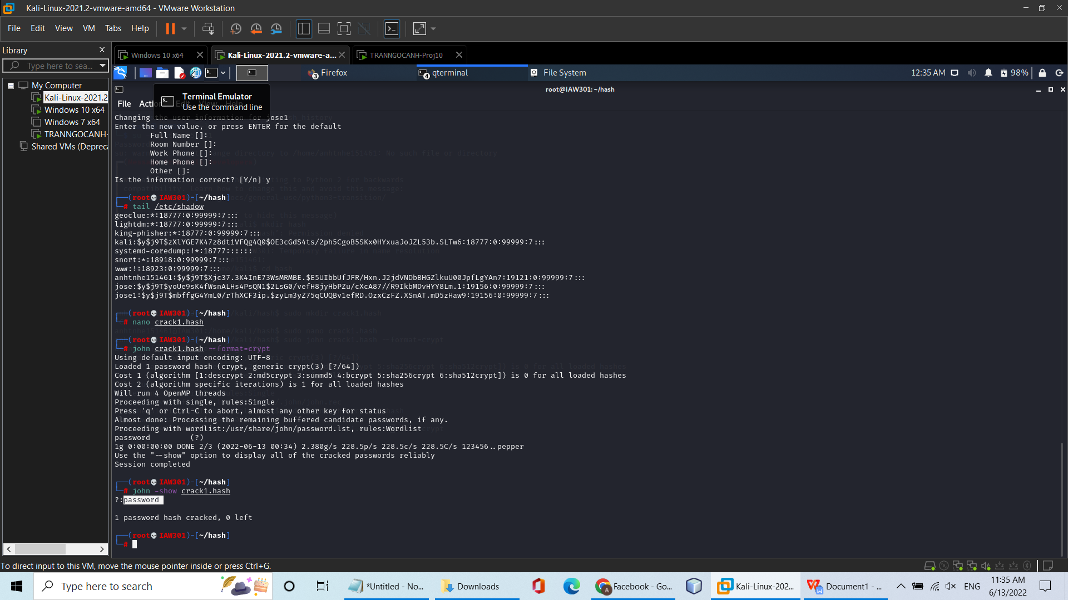

**Getting the crack2.hash List**

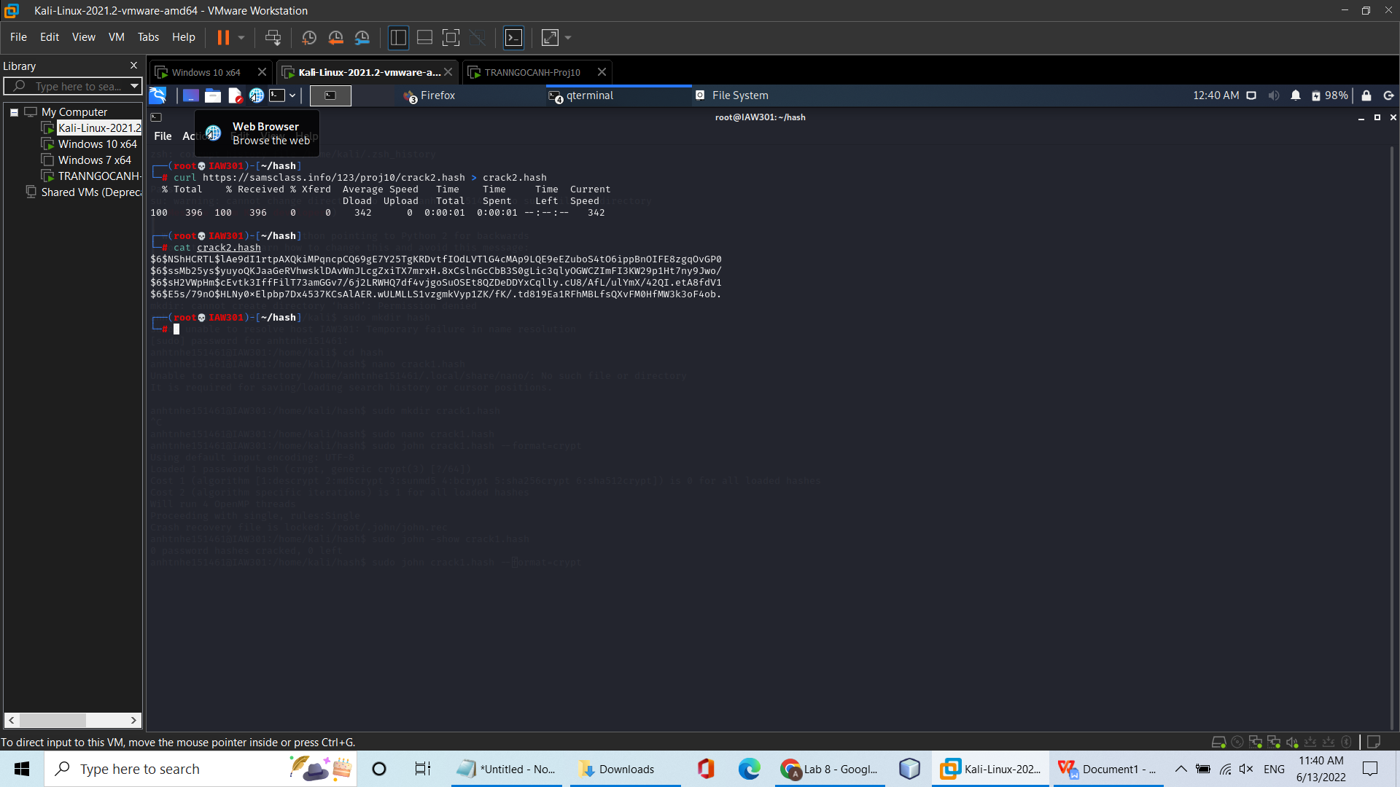

**Cracking the Hashes**

